***Insertion Sort***

**Insertion sort** is a simple sorting algorithm that works similar to the way you sort playing cards in your hands. The array is virtually split into a sorted and an unsorted part. Values from the unsorted part are picked and placed at the correct position in the sorted part.

**Characteristics of Insertion Sort:**

* This algorithm is one of the simplest algorithm with simple implementation
* Basically, Insertion sort is efficient for small data values
* Insertion sort is adaptive in nature, i.e. it is appropriate for data sets which are already partially sorted.

**Working of Insertion Sort algorithm:**

*Consider an example: arr[]: {12, 11, 13, 5, 6}*

| ***12*** | ***11*** | ***13*** | ***5*** | ***6*** |
| --- | --- | --- | --- | --- |

***First Pass:***

* *Initially, the first two elements of the array are compared in insertion sort.*

|  |  |  |  |  |
| --- | --- | --- | --- | --- |
| ***12*** | ***11*** | *13* | *5* | *6* |

* *Here, 12 is greater than 11 hence they are not in the ascending order and 12 is not at its correct position. Thus, swap 11 and 12.*
* *So, for now 11 is stored in a sorted sub-array.*

|  |  |  |  |  |
| --- | --- | --- | --- | --- |
| ***11*** | ***12*** | *13* | *5* | *6* |

***Second Pass:***

* *Now, move to the next two elements and compare them*

|  |  |  |  |  |
| --- | --- | --- | --- | --- |
| *11* | ***12*** | ***13*** | *5* | *6* |

* *Here, 13 is greater than 12, thus both elements seems to be in ascending order, hence, no swapping will occur. 12 also stored in a sorted sub-array along with 11*

***Third Pass:***

* *Now, two elements are present in the sorted sub-array which are****11****and****12***
* *Moving forward to the next two elements which are 13 and 5*

|  |  |  |  |  |
| --- | --- | --- | --- | --- |
| *11* | *12* | ***13*** | ***5*** | *6* |

* *Both 5 and 13 are not present at their correct place so swap them*

|  |  |  |  |  |
| --- | --- | --- | --- | --- |
| *11* | *12* | ***5*** | ***13*** | *6* |

* *After swapping, elements 12 and 5 are not sorted, thus swap again*

|  |  |  |  |  |
| --- | --- | --- | --- | --- |
| *11* | ***5*** | ***12*** | *13* | *6* |

* *Here, again 11 and 5 are not sorted, hence swap again*

|  |  |  |  |  |
| --- | --- | --- | --- | --- |
| ***5*** | ***11*** | *12* | *13* | *6* |

* *here, it is at its correct position*

***Fourth Pass:***

* *Now, the elements which are present in the sorted sub-array are****5, 11****and****12***
* *Moving to the next two elements 13 and 6*

|  |  |  |  |  |
| --- | --- | --- | --- | --- |
| *5* | *11* | *12* | ***13*** | ***6*** |

* *Clearly, they are not sorted, thus perform swap between both*

|  |  |  |  |  |
| --- | --- | --- | --- | --- |
| *5* | *11* | *12* | ***6*** | ***13*** |

* *Now, 6 is smaller than 12, hence, swap again*

|  |  |  |  |  |
| --- | --- | --- | --- | --- |
| *5* | *11* | ***6*** | ***12*** | *13* |

* *Here, also swapping makes 11 and 6 unsorted hence, swap again*

|  |  |  |  |  |
| --- | --- | --- | --- | --- |
| *5* | ***6*** | ***11*** | *12* | *13* |

* *Finally, the array is completely sorted.*

***Illustrations:***

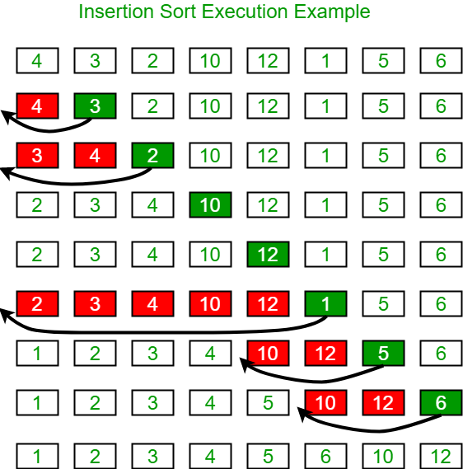

**Insertion Sort Algorithm**

To sort an array of size N in ascending order:

* Iterate from arr[1] to arr[N] over the array.
* Compare the current element (key) to its predecessor.
* If the key element is smaller than its predecessor, compare it to the elements before. Move the greater elements one position up to make space for the swapped element.

**Implementation**

C++Java

// Java program for implementation of Insertion Sort

class InsertionSort {

/*Function to sort array using insertion sort*/

void sort(int arr[])

{

int n = arr.length;

for (int i = 1; i < n; ++i) {

int key = arr[i];

int j = i - 1;

/* Move elements of arr[0..i-1], that are

greater than key, to one position ahead

of their current position */

while (j >= 0 && arr[j] > key) {

arr[j + 1] = arr[j];

j = j - 1;

}

arr[j + 1] = key;

}

}

/* A utility function to print array of size n*/

static void printArray(int arr[])

{

int n = arr.length;

for (int i = 0; i < n; ++i)

System.out.print(arr[i] + " ");

System.out.println();

}

// Driver method

public static void main(String args[])

{

int arr[] = { 12, 11, 13, 5, 6 };

InsertionSort ob = new InsertionSort();

ob.sort(arr);

printArray(arr);

}

} /* This code is contributed by Rajat Mishra. */

**Output**

5 6 11 12 13

**Time Complexity:** O(N^2)   
**Auxiliary Space:**O(1)